

**MATHEMATICS DEPARTMENT**

**Year 12 SPECIALIST MATHEMATICS**

**TEST 3: INTEGRATION**

DATE: 6th April 2016 Name____________________________________

**Reading Time:** 3 minutes

**SECTION ONE: CALCULATOR FREE**

TOTAL: 35 marks

EQUIPMENT: Pens, pencils, pencil sharpener, highlighter, eraser, ruler, SCSA formula sheet.

WORKING TIME: 35 minutes (maximum)

**SECTION TWO: CALCULATOR ASSUMED**

TOTAL: 19 marks

EQUIPMENT: Pens, pencils, pencil sharpener, highlighter, eraser, ruler, drawing instruments, templates, up to 3 Calculators,

1 A4 page of notes (one side only), SCSA formula sheet.

WORKING TIME: 20 minutes (minimum)

|  |  |  |  |  |  |
| --- | --- | --- | --- | --- | --- |
| **SECTION 1**  **Question** | **Marks available** | **Marks awarded** | **SECTION 2**  **Question** | **Marks available** | **Marks awarded** |
| **1** | **10** |  | **6** | **5** |  |
| **2** | **8** |  | **7** | **6** |  |
| **3** | **4** |  | **8** | **8** |  |
| **4** | **6** |  |  |  |  |
| **5** | **7** |  |  |  |  |
|  |  |  |  |  |  |
| **Total** | **35** |  |  | **19** |  |

**Calculator-free [35 marks]**

This paper has **Five (5)** questions. Answer **all** questions. Write your answers in the spaces provided

**Question 1 [10 marks]**

Determine the following indefinite integrals.

1. ** [3]**
2. ** [3]**
3. **  [4]**

**Question 2 [8 marks]**

Evaluate:

1.  **[3]**
2.   **[5]**

**Question 3 [4 marks]**

The curves below areand. Determine the area of the shaded region.

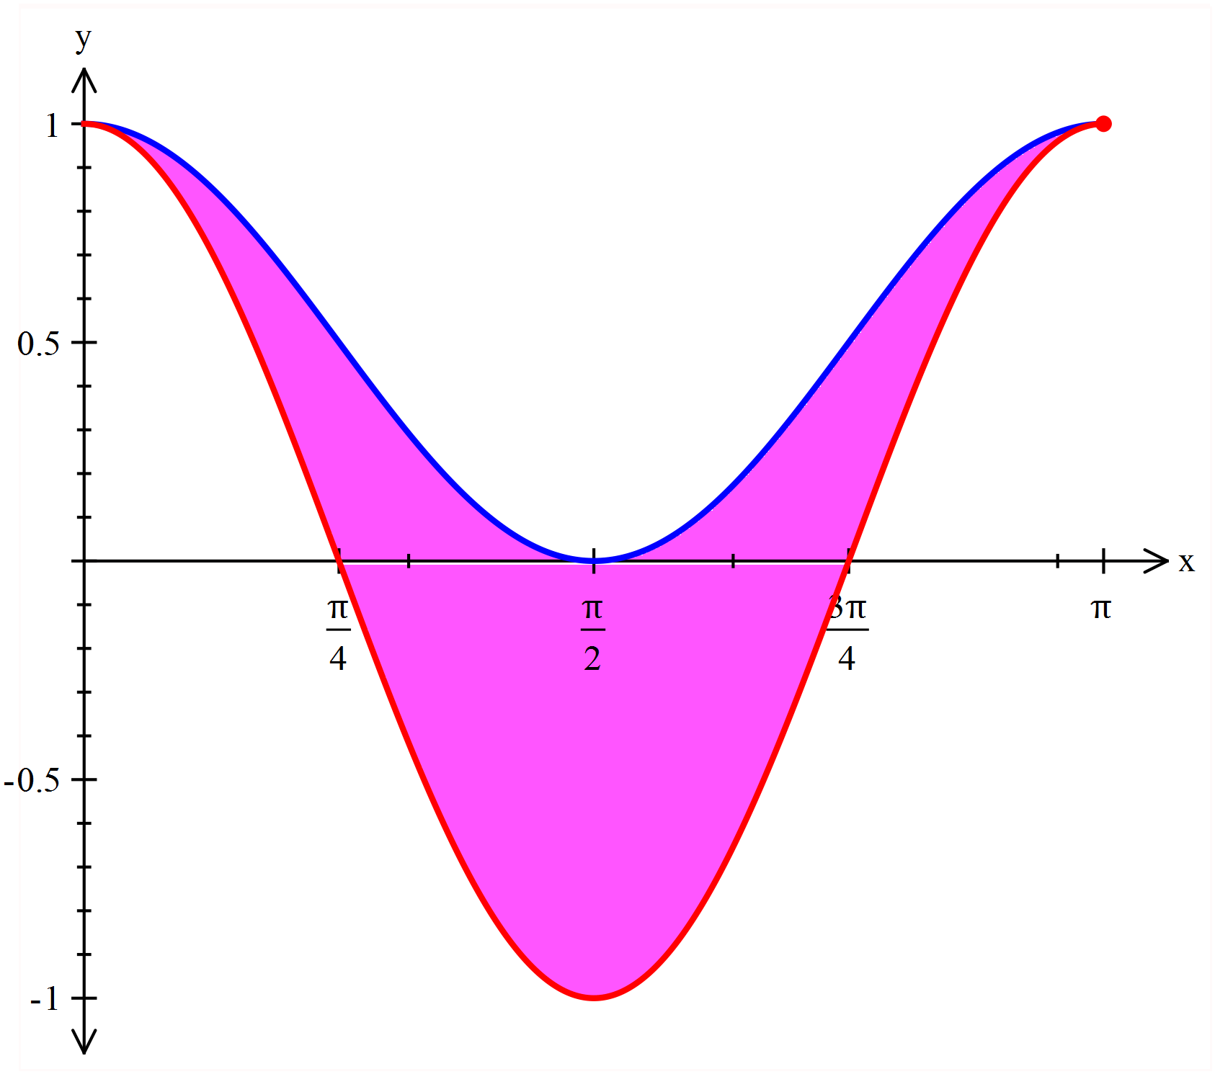

**Question 4 [6 marks]**

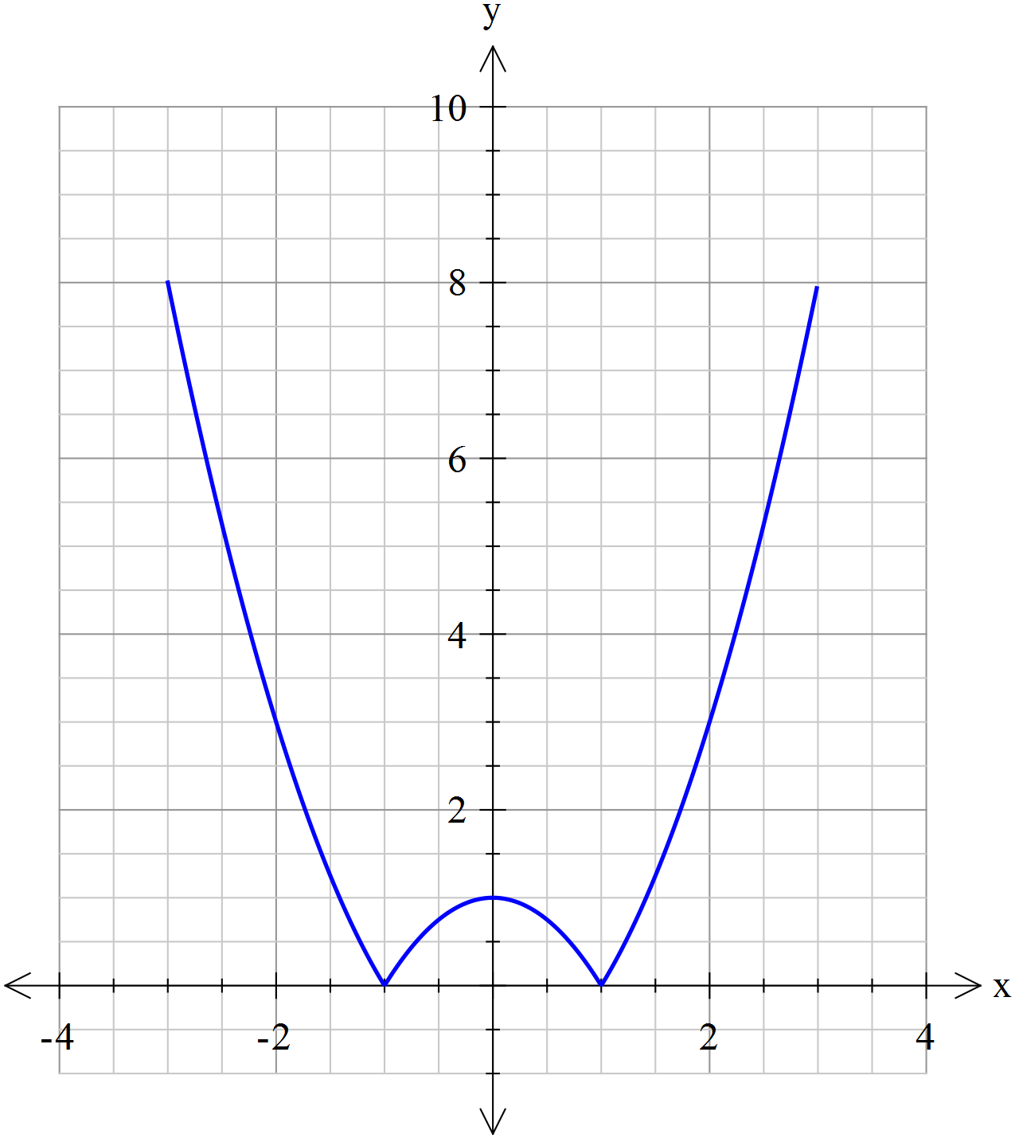

A glass is formed by rotating the function  about the y-axis as shown in the diagram.

1. Complete the middle line for the piecewise function for .



**[1]**

1. Given the height of the glass is 8 cm determine the volume of the glass. **[5]**

**Question 5 [7 marks]**

Find  using the substitution *x* = 2 sin *θ*.

**NAME:……………………………………………………………………………………**

**Calculator Allowed 20 minutes [19 marks]**

This paper has **Three (3)** questions. Answer **all** questions. Write your answers in the spaces provided

**Question 6 [5 marks]**

Determine the value of p in the system of linear equations below such that there is



1. no solution **[3]**
2. a unique solution **[1]**
3. infinitely many solutions **[1]**

**Question 7 [6 marks]**

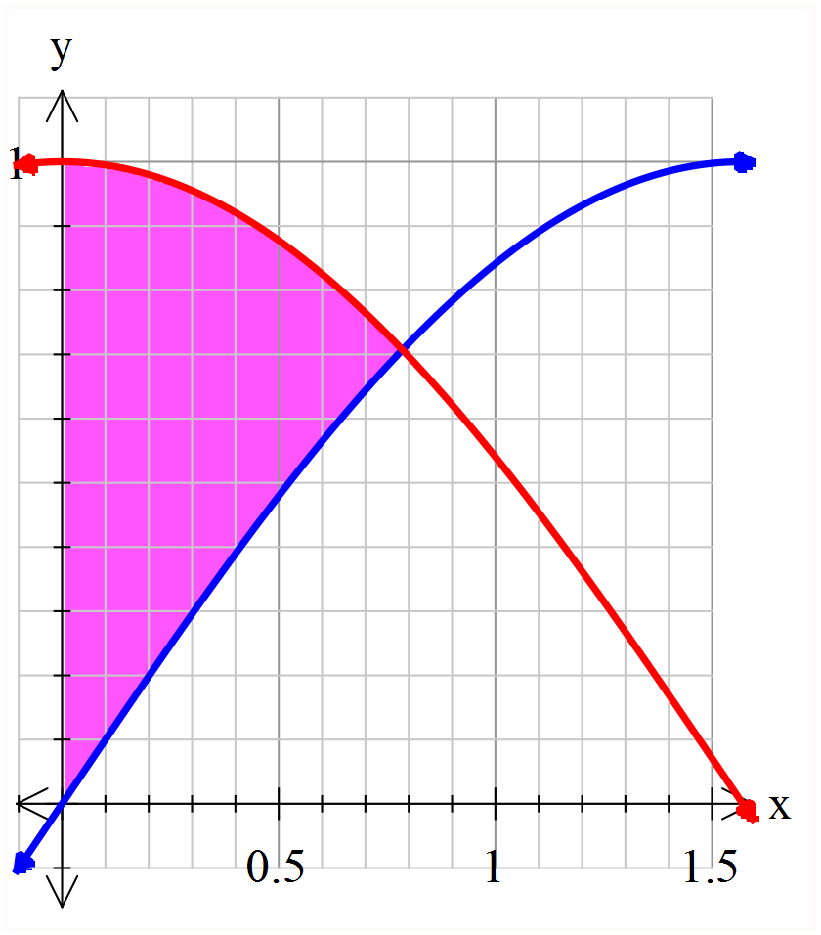

The graph at the right show the curves  and .

1. Prove that the intersection of  and , is 

for the domain .

**[1]**

1. Determine the exact area of the region (shaded) which is bounded by the *y*-axis and the curves

and. **[2]**

1. Determine the volume of revolution obtained when this area is rotated about the *x*-axis.  **[3]**

**Question 8 [8 marks]**

1. Use the identity  to prove that  **[2]**
2. Find a similar expression for  **[2]**
3. Hence show that  **[4]**

**END OF QUESTIONS**